How to Turn in Your Visual Studio 2019 Project

1. Close your project. Find the folder containing your project. Open the folder:

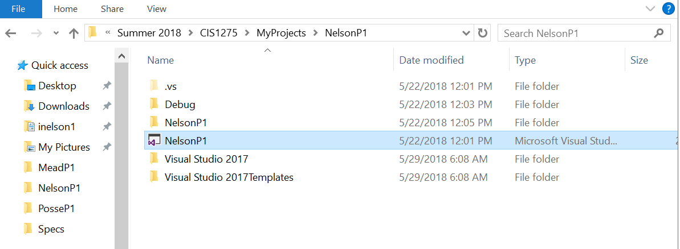

1. Notice the .vs folder. It may be hidden on your computer. If so, you need to un-hide it. Click on the View tab at the top, and you will see this toolbar. Check to see the Hidden Items :

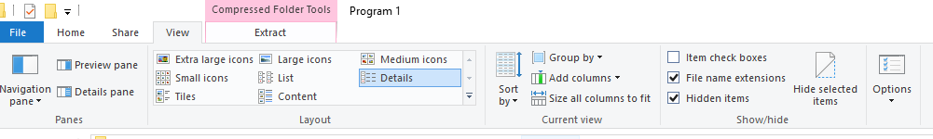

1. Click three times on the .vs folder. You will see your folder name again,NelsonP1, then v16, then this screen:

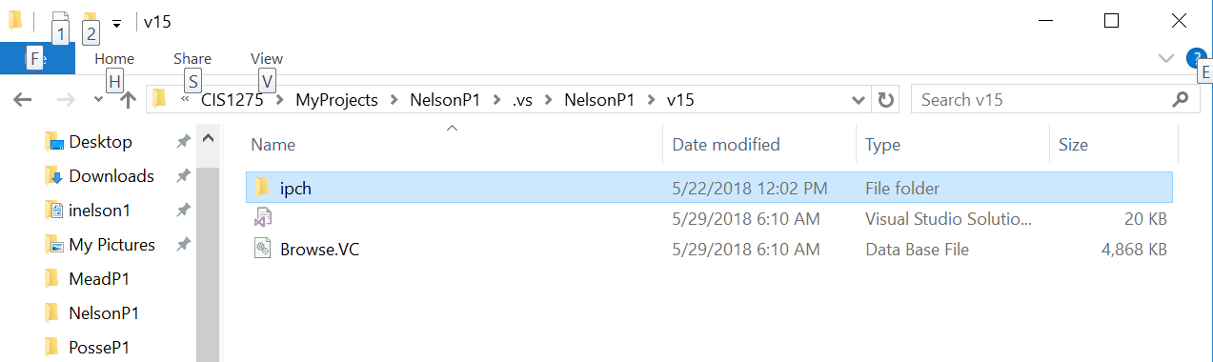

1. Delete the ipch folder and the Browse.VC file.
2. **Leave the Visual Studio User Options.suo file**, the one in the middle. This one contains the settings you create.
3. Now go back up three levels to the NelsonP1 folder that holds the .vs folder.
4. Delete the Debug folder. Your project may have X64 folders instead of debug folders. They contain the debug folders. Delete X64.
5. Open the inner Project folder, NelsonP1

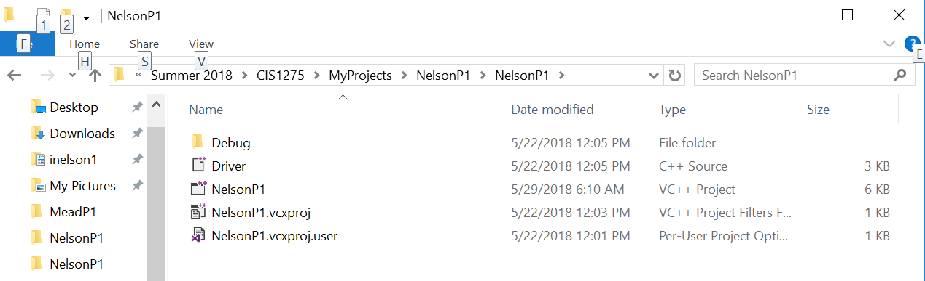

1. Delete the Debug and/or X64 folder you find here.
2. Close your project folder and zip it with Windows compression.
3. Now you can upload it to Brightspace